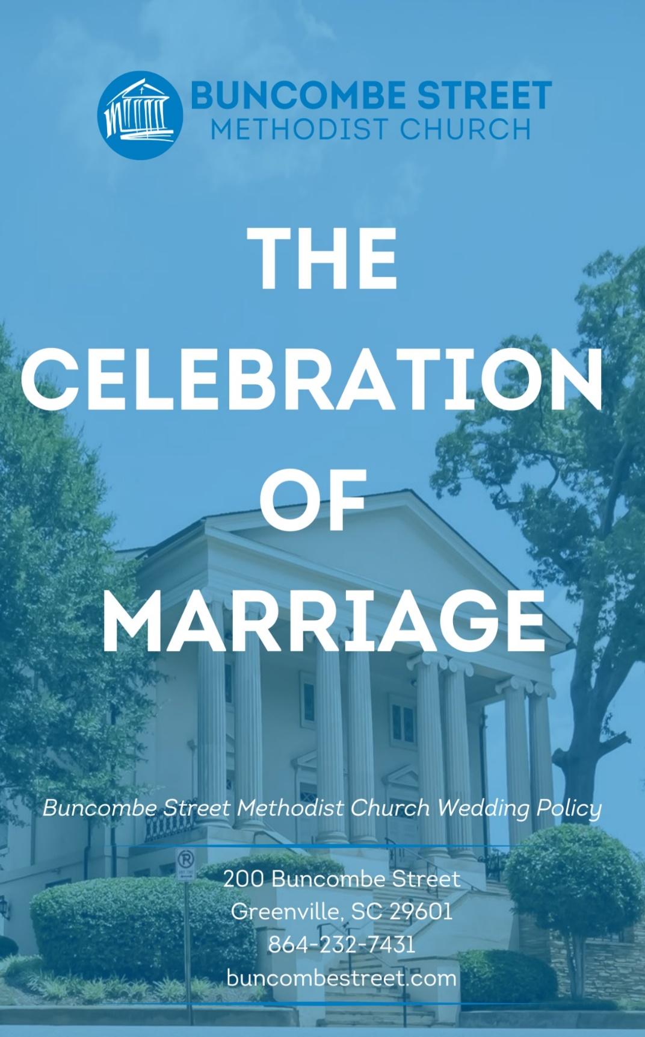

*This booklet contains the Buncombe Street Methodist Church Wedding Policy.*

Rev. October 2025

Table of Contents

**Page No.**

A Little About Us 4

Introduction 5

What to do first 6

Facilities 7

Ministers 9

The Wedding Committee 9

Music for Your Wedding 10

Decorations & Flowers 10

Crucifer 13

The Wedding Party 13

Rehearsal 14

Parking 15

Rules of Decorum 16

Charges and Honorarium 17

Wedding Fee Worksheet 18

Wedding Planner Timeline 19

Suggested Order of Worship for Weddings 20

Wedding Contacts 21

Information & Guidelines for Wedding Florists 22

Information & Guidelines for Wedding Photographers 23

Notes 24

A Little About Us

The Church was founded in 1834 and the new Buncombe Street building was dedicated in 1873. However, the seed of its existence was planted on that day in 1832 when Vardry McBee deeded a frame building on Coffee Street to the Methodist Denomination. This Church has watched and been an integral part of Greenville’s growth from a small village to a major metropolitan area. Down through the years our parishioners have diligently worked hard to respond to the needs of our growing and thriving congregation as well as to the community at large. The Church ministries continue to evolve to help meet these needs. With pride and joy the Church has been able to make at least six significant expansions and renovations to its facilities.

Mr. McBee’s seed of gracious generosity has grown and blossomed many times over in the past 190 years. With the love and dedication of Buncombe Street Methodist Church parishioners, it will continue to be the beautiful and thriving Church it is today.

Buncombe Street Methodist Church is humbly honored that you are considering choosing this venue for your wedding. Many precious unions of marriage have been witnessed at this Church in its 190 years of existence and your union would proudly give it one more golden glorious memory to add to its history.

This booklet was designed to provide you with information and guidelines to follow in the planning and preparation of your wedding. If you need any further information or have questions or concerns, please call the Church office at 864-232-7341 anytime Monday through Thursday from 8:30 a.m. to 5:00 p.m. and Friday from 8:30 a.m. to 1:00 p.m.

Introduction

We must always keep in mind that a Christian wedding ceremony is a worship service and those invited to share in the ceremony are fellow worshippers and not just spectators. As you would expect as a fellow worshipper, all aspects of your service will be conducted with dignity and reverence and in keeping with the liturgy, ritual, and traditions of this Church.

We are pleased to offer our members two beautiful worship spaces perfect for weddings. The larger space is the Church Sanctuary, and the smaller space is the Memorial Chapel.

It is Buncombe Street Methodist Church’s policy that any member may use the Sanctuary or Memorial Chapel for weddings. Also, that member’s children may use the facilities for weddings. All weddings will be scheduled at the discretion of the Church.

There are a few times throughout the year that the Church would not be available for weddings. Weddings will not be scheduled during the following times:

* Easter weekend
* The weekend after Thanksgiving
* During the season of Advent
* Christmas Eve, Christmas Day, New Year’s Eve, or New Year’s Day.

What to do first

If you have access to a computer, please go to the Buncombe Street Methodist Church website to obtain all the information for weddings that you will need regarding weddings. To go online, please go to [www.buncombestreet.co](http://www.buncombestreet.co)m, click on the MENU on the left side of the screen, click on About and then click on Baptisms, Weddings, Funerals and then click on Weddings. This booklet can be obtained electronically by clicking on Wedding Policy in this window. Once you have read through this booklet go back to the same page on the website and click on the Wedding Information Sheet. By completing and submitting this form you will give us the information we need to add your wedding to our calendar once it has been approved. After you have completed these steps, please contact the Church office to confirm that your request has been approved.

If you do not have access to a computer, please call the Church office to request a copy of the BSMC Wedding Policy and after you have read and fully understand this Policy call the Church office to set up an appointment to come in and complete the necessary request forms.

Once your wedding has been approved and the rehearsal and wedding dates have been scheduled, below are the first steps to take in preparation for your big day. Please contact the Church office regarding the following:

1. Provide two minister choices for your wedding ceremony.
2. Confirm your rehearsal and wedding dates have been scheduled.
3. Request your two choices of a minister to help you prepare your wedding day and perform your ceremony. Once a minister has been appointed you will be notified. Please contact the church to set up appointments for the required premarital counseling. Provide six available dates for premarital counseling.

1. Contact Director of Music to discuss wedding music.   
   *(Extra music or a soloist must be approved by the Director of Music.)*

Facilities

The main sanctuary will seat approximately 800 guests and the Memorial Chapel will seat approximately 200 guests.

Our church facilities are also available for receptions following wedding ceremonies. Receptions may be held in the Truluck Room, which seats 50. Arrangements for the reception (including music and any decorations) must be approved by the church administration.

Any family members or participants in the wedding ceremony who must arrive early are welcome to wait in the Parlor until it is time to begin seating for the wedding.

A suitable space will be made available as a dressing area for the bride and her attendants. The bride is asked to designate someone to collect any remaining items left at the church or in the dressing area as the church cannot be responsible for any articles left in the church or in the bride’s dressing area after the wedding.

The groom and the groomsmen will be provided a Sunday School classroom

If additional space or assistance is required, please contact the Church office with your request. Our facility is equipped with an elevator and wheelchairs for those who will need assistance.

Our church doors remain locked for the safety of the children and our staff, but they will be unlocked during specific timeframes for special occasions. For your wedding, the Church doors will be unlocked thirty (30) minutes prior to rehearsal and two (2) hours prior to the wedding.

Wedding ceremonies will not be scheduled to begin after 7:00 p.m.

Buncombe Street Methodist Church takes pride in keeping its facility and all surrounding outside areas clear of any debris; therefore, we must ask that no rice, confetti, or any other materials be thrown in any part of the building, outside walks, outside stairways, driveways, or parking lots.

Furthermore, our Church has always taken the necessary steps to assure that everyone experiences a healthy, clean, and safe environment. It will bring you peace of mind to know that in and on all Church property, inside and outside, smoking, alcohol, illegal drugs, or any illegal activity are all prohibited, and violators will be dealt with accordingly.

Childcare is not provided or allowed during rehearsal or wedding times due to the Church Safe Sanctuary Policies.

Ministers

Weddings at Buncombe Street Methodist Church may be performed, by one or more of our staff ministers.

If you wish to have a visiting minister to assist in the ceremony, please submit your request to the Buncombe Street Methodist Church minister that has been assigned to your wedding. Your assigned minister must oversee all aspects of your service.

Please arrange to have your marriage license given to your Buncombe Street Methodist Church assigned minister no later than the evening of the rehearsal.

The bride and groom must meet with their assigned minister for required premarital counseling.

The Wedding Committee

Buncombe Street Methodist Church takes every measure possible to assure that your wedding is a success. To ensure this, you will be assigned a wedding director. After you have reserved the church facilities and been assigned a minister and organist, your wedding director will contact you to arrange a meeting to discuss your wedding plans. The Buncombe Street Methodist Church Wedding Committee volunteers will be present at both the rehearsal and the wedding ceremony to direct, instruct, and assist you and members of your wedding party.

Music for Your Wedding

The Church Director of Music will meet with you to discuss your selections of sacred and classical music for the ceremony. Please keep in mind that all music, instrumentals, and vocals will need to follow the standards of dignity and formality of traditional worship at Buncombe Street Methodist Church.

Your music selections must be finalized at least four (4) weeks prior to the rehearsal. All music selections and/or any additional musicians must be approved by the Director of Music.

It is church policy that all musicians wear choir vestments or black attire.

Please schedule a meeting with the Music Director at least six weeks before the wedding.

Decorations and Flowers

Elegance and simplicity go hand in hand for a Buncombe Street Methodist Church wedding. The use of fresh flowers, greens, and candles should enhance the religious ceremony and not overwhelm it. To help protect our beautiful spaces and to keep safety and simplicity in mind, below are a few restrictions:

* Flowers or decorations may not be used on the pews.
* Pew torches may not be decorated.
* Flowers or ribbons should not be placed outside the Church.
* Tacks, nails, scotch tape, pins, wire, or other attachments may not be used on any furniture, walls, woodworking, or carpeting.
* Furniture may not be moved.
* Because there is no satisfactory way of safely using an aisle cloth, our policy does not allow the use of one.

Flowers

Only fresh flowers or greenery may be used for the Altar and the bridal party. Flowers or greenery will be left for the Sunday services. Flowers may be dedicated in memory or in honor of loved ones.

All flower arrangements **MUST** be placed in a strong container that can stand on its own and that can be easily transferred to the cooler and back to the altar the following Sunday.    No flower arrangements are to be placed inside the church’s expensive brass urns without being in a container.

Two flower arrangements, placed on either side of the Altar, are required in the Memorial Chapel, and recommended in the sanctuary. However, for sanctuary weddings, the bride may elect to have only one center arrangement on the Altar.

All flowers should be in the church at least two (2) hours before the ceremony. Please contact the Church Office at (864) 232-7341 for the best time to deliver.

Specific dimensions for the Altar arrangements in each worship space are as follows:

Sanctuary Flowers – Attached is a form to provide information to your florist.

For two arrangements, flowers are placed in urns furnished by the church and will be placed on both sides of the Altar ONLY**.** The dimensions are the following:

Measurement of liner:

Width 9” (across top and lip) – Depth 7 ½” -Bottom depth 5 ½”

Size of arrangements (not including provided urns):

For 2 arrangements:

Height 32” (from top of liner) – Width 32”

For one arrangement, flowers should be placed in a shallow container and will be placed on the center of the altar ONLY. The dimensions are the following:

Height 32” – Width 38”

Note: The flowers may not cover any of the crosses on the altar.

Memorial Chapel Flowers

For two arrangements, flowers are placed in urns furnished by the church and will be placed on both sides of the Altar ONLY. Urn liners are available for the florist to borrow upon request. The dimensions are the following:

Measurement of liner:   
Width 6” (across top & lip) – Depth 9.5”

Size of arrangements:  
Height 24” (from top of liner) – Width 18”

Candles

Candles, provided by the church, will be used on the Altar. The Paschal Candle will be lit. Additional candles will not be allowed in the Chancel.

Pew Torches

Torches are available for use in the Sanctuary. They are used in pairs and are placed on the center aisle ends of the pews. The pew torches may **not** be decorated. There is a rental fee of $10 for each pair of torches.

Bride’s Book

Please reserve your Bride’s Book for the reception. The Bride’s Book is not used at the church before the wedding to assure ample time for seating guests.

# Crucifer

All wedding processions will begin with a crucifer carrying the cross to the Altar. The church will provide the crucifer from a pool of our youth members who have been trained to perform this role during weddings. All members of the wedding party will follow in the procession.

# The Wedding Party

Bridesmaids

Because of the limited space, the number of bridesmaids is limited to twelve (12) in the sanctuary and five (5) in the Chapel.

A suitable space will be made available as a dressing area for the bride and her attendants. Since the church cannot be responsible for any articles left at the church or in the bride’s dressing room, attendants are encouraged to gather their belongings in an appropriate manner before the ceremony. The bride should designate someone to collect any remaining items.

 Flower Girls/Ring Bearers

These, if used, are symbolic. Flower petals or confetti may not be dropped on the aisles. Limited two (2) of each. Children must be age 5 or older.

Ushers/Groomsmen

Generally, the number of ushers/groomsmen is equal to, or slightly larger than, the number of bridesmaids. The Wedding Committee will provide instruction for their duties. One usher per 50 guests is recommended.

## Reader

A reader should dress in pulpit-appropriate attire or robe and will be seated in the chancel prior to the ceremony.

# Rehearsal

It is necessary that only the bridal party, the parents, and the grandparents attend the rehearsal. Both bride and groom share the responsibility of having their attendants arrive on time. Rehearsals should be completed within one hour in order for the Sexton to lock the building and have it properly prepared for your special day.

# Parking

The lots across from the front of Buncombe Street Church will be reserved for your rehearsal and wedding times. The parking lot vendor should not ticket cars for parking for your rehearsal or wedding, however it is only for the duration of the events. Cars parked longer than the duration of the events could receive a ticket.

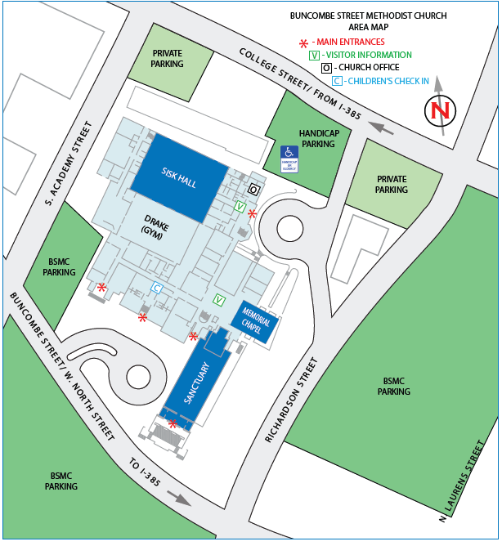

# **Rules of Decorum**

The wedding rehearsal and ceremony are held in a holy place dedicated to the worship of God, and therefore, all participants should act accordingly.

* Alcoholic beverages and/or illegal drugs are not permitted on church property, and members of the wedding party shall not come to the rehearsal or the wedding under the influence of alcohol or drugs. No member of the wedding party under the influence will participate in the rehearsal or wedding.
* It is important that the wedding party will be on time for both the rehearsal and the determined arrival time on the wedding day.
* It is important that the wedding begins exactly on time. Guests who arrive after the mothers are seated will be seated at the discretion of the wedding director.
* No photos should be allowed to be taken by guests during the wedding ceremony. It is the responsibility of the bride and groom to advise their guests of this policy.
* Out of respect for the musicians, it is appropriate to refrain from talking after the prelude has begun

# Charges and Honorarium

Note: Checks should be payable to individual vendor and placed in individual envelopes. You will be given a large envelope in which to place the individual envelopes.

**Organist**

Consultation, Rehearsal and Wedding $500

**Clergy (includes 3 premarital counseling sessions)**

Rehearsal and Wedding $500

**Vocalist/Instrumentalist** (Contact individual for pricing)

**Crucifer** $40

**Sound System Operator** (Sanctuary weddings only) $100

**Sexton** $200

**Reception**

Truluck Room $100

**Decorative Items:**

Pew Torches – 9 pairs $10/Pair  
*(To be set up by Sexton)*

# Wedding Fee Worksheet

Organist $___________________

Clergy $___________________

Director $___________________

Instrumentalist(s) $___________________

Vocalist(s) $___________________

Crucifer $___________________

Sexton $___________________

Sound System Operator $___________________

*Safety/Traffic Officer $___________________

*Reception $___________________

*Pew Torches $___________________

*Payable to Buncombe Street Methodist Church

**TOTAL DUE ONE WEEK PRIOR TO WEDDING** $___________________

*Fees and honorariums should be submitted to Buncombe Street Methodist Church office* ***no later than one week prior to the wedding****. You will be asked to place the envelopes in the Church Wedding Director’s mailbox.*

Your Wedding Director will disperse to appropriate individuals prior to wedding.

**Wedding Planner Timeline**

|  |  |  |  |  |  |  |  |
| --- | --- | --- | --- | --- | --- | --- | --- |
|  | **Meetings:**  Clergy  Director of Music  Wedding Director | Closed Book | **Forms:**  Wedding Information Sheet  Wedding Details Form | Pencil | **Fees:**  Clergy, Organist, etc. | $ |  |

|  |  |  |
| --- | --- | --- |
|  | Complete by | ACTIONS TO TAKE |
| □ | 9-12 Months Prior | Review the Buncombe Street Methodist Church Wedding Policy (*The Celebration of Marriage* booklet) |
| □ | 9-12 Months Prior | Fill out and submit the Wedding Information Sheet |
| □ | 9-12 Months Prior | If no conflicts arise, dates and spaces will be reserved, a Wedding Director will be assigned, and confirmations will be emailed. |
| □ | 9-12 Months Prior | Confirm clergy to officiate wedding |
| □ | 6 Months Prior | Confirm scheduling of first premarital counseling. |
| □ | 6 Months Prior | Provide vendors with a copy of the Buncombe Street Methodist Church Wedding Policy along with guidelines |
| □ | 4 Months Prior | Confirm scheduling of second premarital counseling. |
| □ | 3 Months Prior | Contact Music Director to schedule a meeting to plan the music and instrumentalists for the wedding. |
| □ | 2 Months Prior | Confirm third premarital counseling, fill out and submit the Wedding Details form, and contact Wedding Director for further planning. |
| □ | 1 Week Prior | Review list of Fees will be sent. Payment may be submitted to the Church Office |
| □ | Wedding Rehearsal | Typically held in the late afternoon or evening prior to the ceremony. (Church must be notified of any last-minute changes in times) |
| □ | Wedding Day | See *Suggested Order of Worship for Weddings*. |

Buncombe Street Methodist Church  
Suggested Order of Worship for Weddings



**Prelude** *(We don’t generally list the titles here)*

**Seating of the Grandmothers and Mothers** (Title Here)

**\*Anthem**

**Chiming of the Hour**

**Wedding Party Processional** (Titles Here–can be 1 or 2 pieces)

**Bridal Processional** (Title Here)

**Greeting**

**Declaration of Intention**

**Presentation of the Bride**

**\*Scripture Readings**

**Homily** (Bride and Groom move up to high altar)

**Exchange Vows**

**Blessing and Exchange of Rings**

**Declaration of Marriage**

**Blessing of Marriage**

**The Lord’s Prayer** (Sung or Spoken by everyone)

**Benediction/Sending Forth**

**\*Choral Benediction**

**Recessional** (Title Here)

**Postlude** (Title Here)

*Items with an asterisk are optional.

**WEDDING CONTACTS**

|  |
| --- |
| **Minister** |
| Name: |
| Phone: |
| Email: |
|  |
| **Music Director** |
| Name: |
| Phone: |
| Email: |
|  |
| **Wedding Director** |
| Name: |
| Phone: |
| Email: |
|  |
| **Church Office** |
| Name: |
| Phone: |
| Email: |
|  |
| **Florist** |
| Name: |
| Phone: |
| Email: |
|  |
| **Photographer** |
| Name: |
| Phone: |
| Email: |
|  |

**Information & Guidelines for Wedding Florists**

The following guidelines have been established by the Church Worship Committee and the Wedding Committee and will be adhered to strictly. All flowers should be in the church at least two (2) hours before the ceremony. Please contact the Church Office at (864) 232-7341 for the best time to deliver. All flower arrangements (both Sanctuary & Memorial Chapel ceremonies) MUST be placed in a strong container that can stand on its own and that can be easily transferred to the cooler and back to the altar the following Sunday.    No flower arrangements are to be placed inside the church’s expensive brass urns without being in a container. The flowers may not cover any of the crosses on the altar. Specific dimensions for the Altar arrangements in each worship space are as follows:

**Sanctuary Flowers**:

For two arrangements, flowers are placed in urns furnished by the church and will be placed on both sides of the Altar ONLY**.**

The dimensions are the following:

Liner Measurement: Width 9” (across top & lip)–Depth 7 ½” -Bottom depth 5 ½”

Size of arrangements (not including provided urns):

For 2 arrangements: Height 32” (from top of liner) – Width 32”

For one arrangement, flowers should be placed in a shallow container and will be placed on the center of the altar ONLY. The dimensions are the following: Height 32” – Width 38”

**Memorial Chapel Flowers:**

For two arrangements, flowers are placed in urns furnished by the church and will be placed on both sides of the Altar ONLY. Urn liners are available for the florist to borrow upon request. The dimensions are the following: Measurement of liner: Width 6” (across top & lip) – Depth 9.5”. Size of arrangements: Height 24” (from top of liner) – Width 18”. Flower Pedals or confetti may not be dropped in the aisles.

(*This page may be removed and given to the florist.*)

**Buncombe Street Methodist Church  
Information & Guidelines for   
Photographers & Videographers**

The following guidelines have been established by the Buncombe Street Methodist Church Worship Committee and the Wedding Committee and will be adhered to strictly:

* Prior to the ceremony, photos may be taken in the narthex or outside the church.
* Other photos may be taken from the narthex as the bride and groom exit the church.
* During the ceremony, photographs may be taken **ONLY** **from the balcony of the sanctuary. Flash may NOT be used**.
* We ask that photographers remember that the wedding ceremony is a worship service and that they refrain from actions that might distract the celebrant or any of the participants.
* Photos after the ceremony, posed and candid, are left to the discretion of the bride and groom.
* In consideration of the friends who attend the reception, avoid long, time-consuming sessions of posed photo-taking which delay the beginning of the reception.
* Video cameras with no lights or noise may be used from the balcony only and are subject to the approval of the Director of Music.

(*This page may be removed and given to the photographer.*)

**Notes**

________________________________________________________________________________________________________________________________________________________________________________________________________________________________________________________________________________________________________________________________________________________________________________________________________________________________________________________________________________________________________________________________________________________________________________________________________________________________________________________________________________________________________________________________________________________________________________________________________________________________________________________________________________________________